**Connecting ADF to ADLS Gen1**

Okay, let’s walk through the steps to connect ADF to ADLS.

Connecting ADF to ADLS is completed through the use of the built-in Linked Services connector.

A linked service can be thought of as a data connector and defines the specific information required to connect to that data source i.e. ADLS, Azure Blob Storage, Azure SQL etc.

**Create the Linked Service**

Within the Data Factory portal select **Connections -> Linked Services** and then **Data Lake Storage Gen1:**

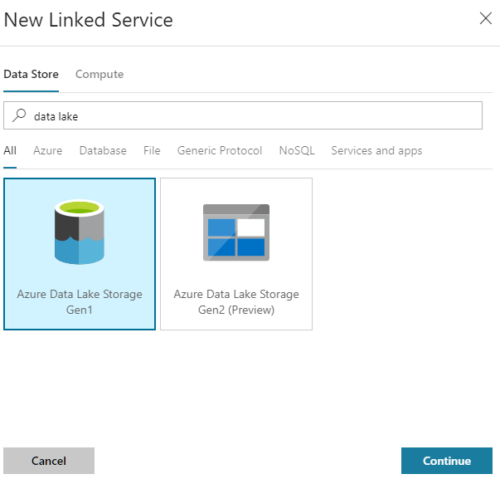

Click **Continue** and we’re prompted to provide the Data Lake store’s details. Assuming you already have a data lake store created go ahead and select your store:

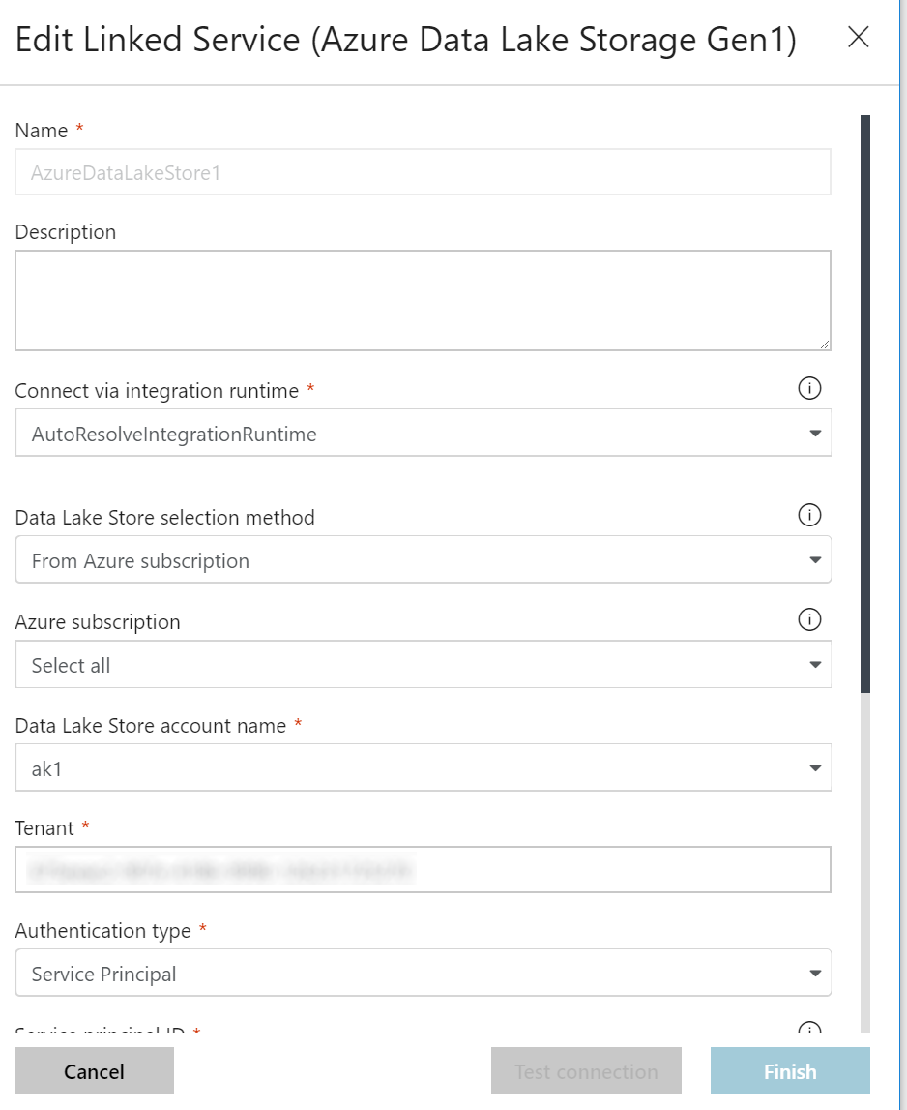

Most of these settings are self-explanatory but the complexities are around the authentication type.

In this example we are going to use a ***Service Principal*** (SPN) in Azure Active Directory (Azure AD). Creating an SPN allows us to grant access to the Data Lake Store by Data Factory.

Selecting the SPN option prompts us for the following information:

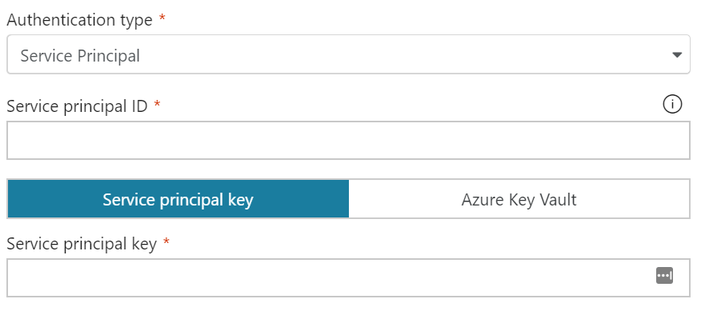

Best practice is to also store the SPN key in Azure Key Vault but we’ll keep it simple in this example.

**Create the Service Principal**

The next step is to create the SPN in Azure AD (you’ll need the appropriate Azure AD permissions to do this).

At this point it’s easiest to open a new browser tab and open another copy of the Azure Portal (we want to come back to the Data Factory config in moment).

Within the Azure Portal select **Azure Active Directory** -> **App registrations**and then**New application registration:**

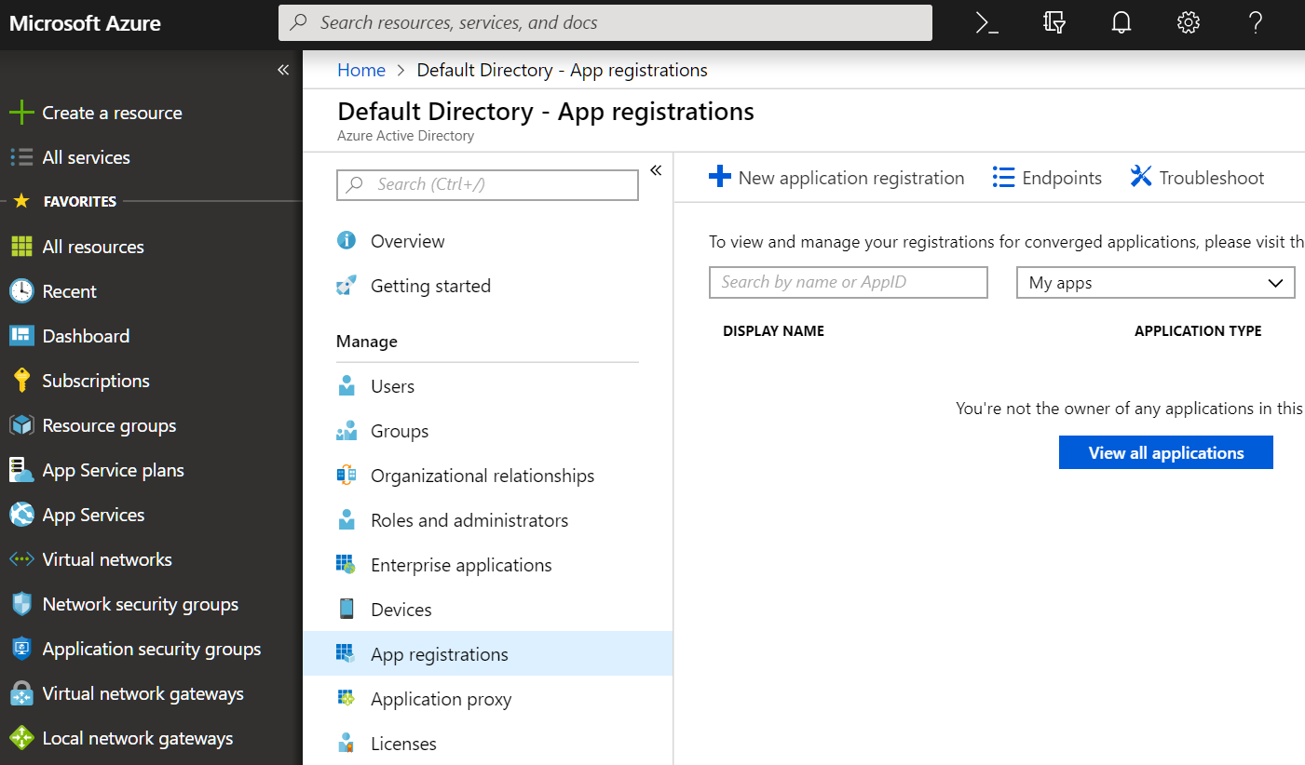

This brings up the **Create** blade. Provide a meaningful name and ensure the type is set to **Web app / API**. The URL isn’t used by ADF so can be any value:

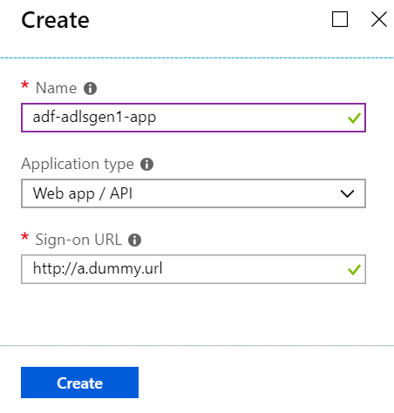

Click the **Create** button to complete the registration of the new application. Once created the applications details will be displayed:

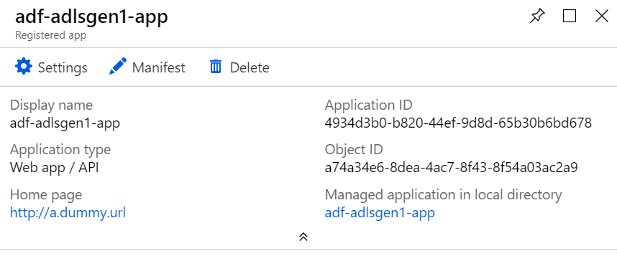

The ***Application ID*** is actually what ADF refers to as the ***Service principal ID***. **Copy** the Application ID, switch back to the other browser tab with Data Factory and **paste** the ID into the field:

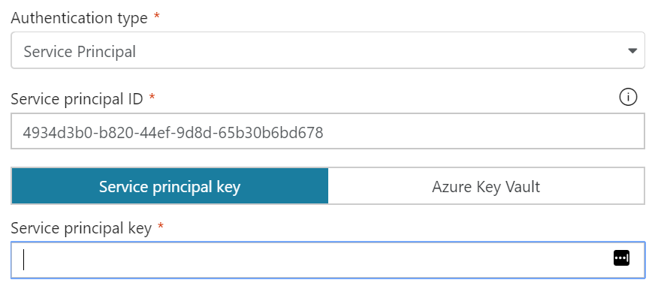

**Generate a Service Principal Key**

The next step is to generate the SPN key. Back in the **Registered app** blade for our SPN select **Settings** and then **Keys:**

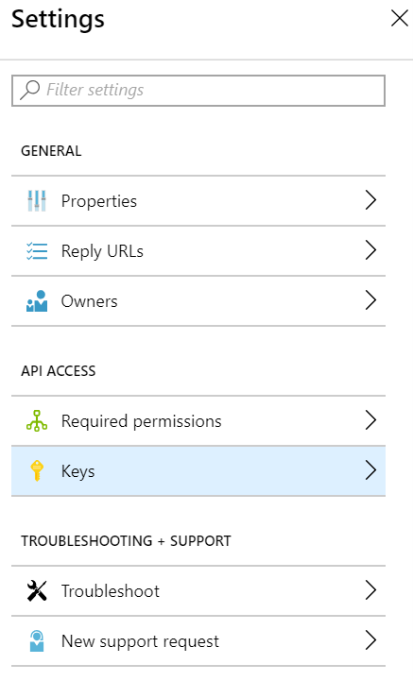

Enter a password **description** and **expiry:**

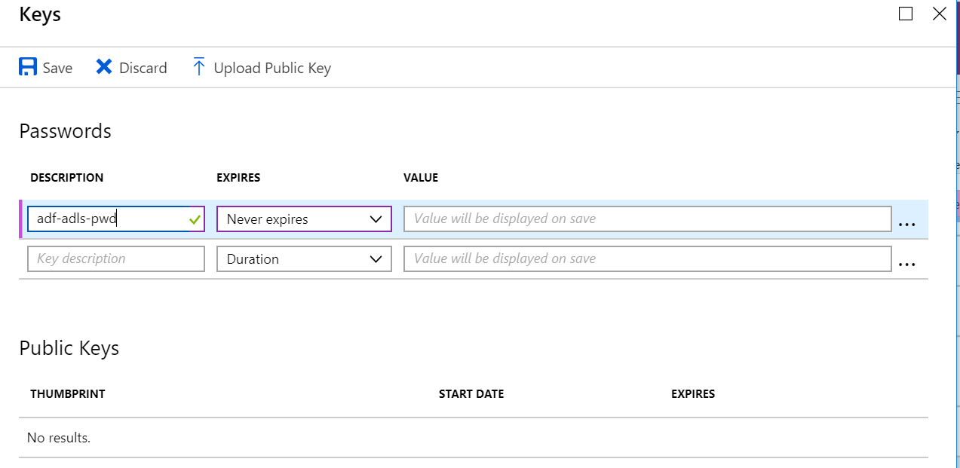

Click**Save**, and copy the key value that is generated:

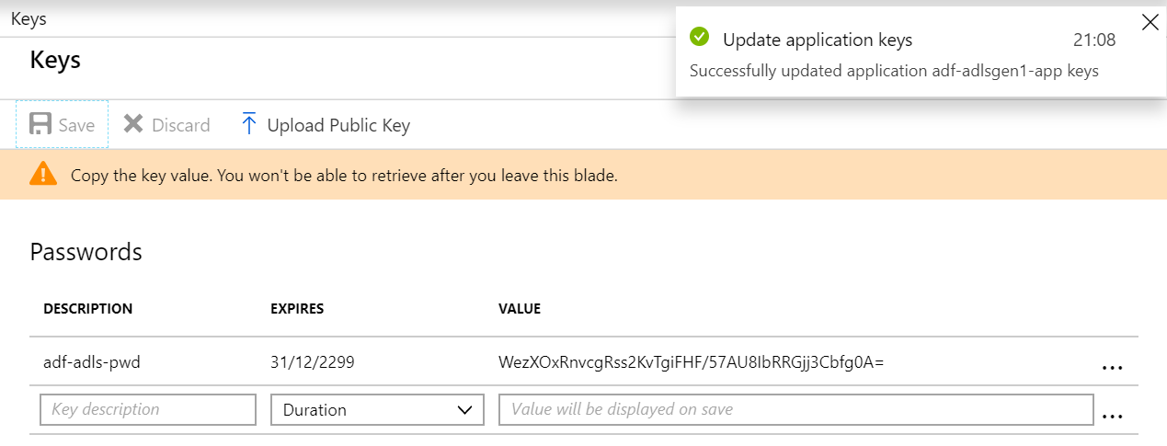

Switch back to Data Factory and **paste** in the key:

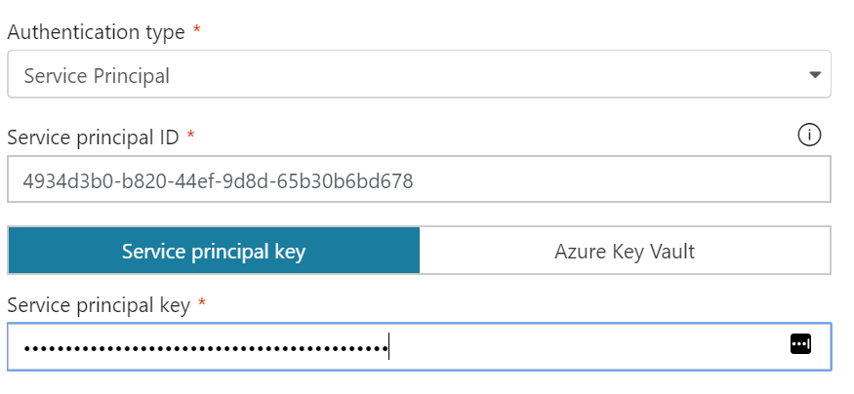

Click **Finish** to close the linked service. We’ll come back to it later to retest once we’ve assigned the required permissions.

We now need to explicitly grant permissions to Data Factory so that it can manipulate data in our Data Lake.

As you’ll see below assigning the permissions is quite convoluted so I’ve separated these into steps 1–3 below.

#### ****Permissions — Step 1****

Return to the registered app in **Azure AD**, select **Settings** -> **Required Permissions:**

*note — if you’ve navigated away from the Azure AD blade you’ll find your app under****App registrations****in Azure AD*

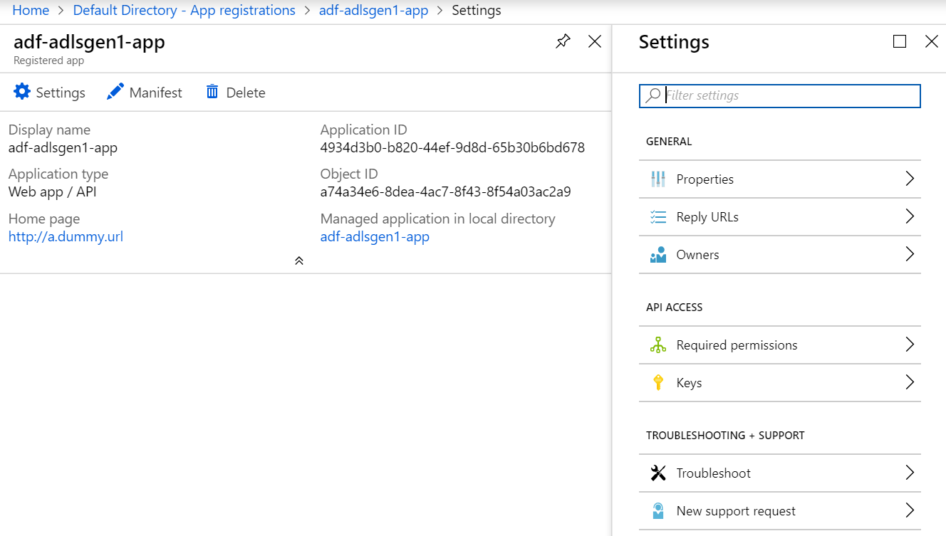

Click on**Add:**

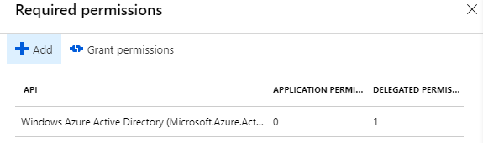

Under **Select an API** highlight **Azure Data Lake** and click **Select:**

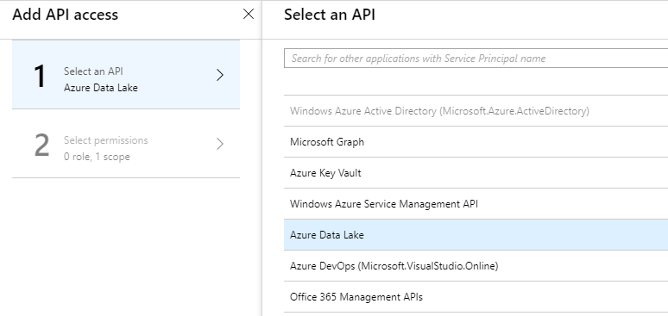

Under **Select permissions** ensure **Delegated Permissions** are highlighted. Click **Select**and then**Done**:

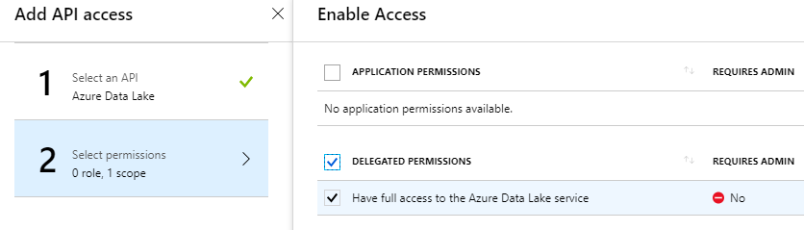

The first set of permissions have now been added:

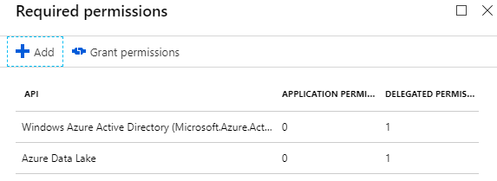

#### ****Permissions — Step 2****

We now need to grant the Registered App (SPN) permissions to our Data Lake. This is completed via the Access control (IAM) blade for the Data Lake Analytics account.

Locate your Data Lake Analytics account, select **Access control (IAM)** and click **Add**:

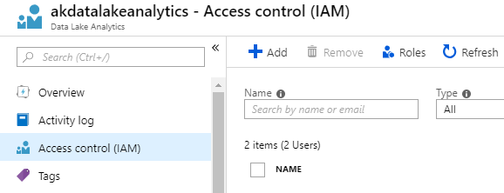

Select the **Data Lake Analytics Developer** role, enter the Registered App name and click **Save:**

*note: you may need type the App name manually if it doesn’t appear in the list of objects*

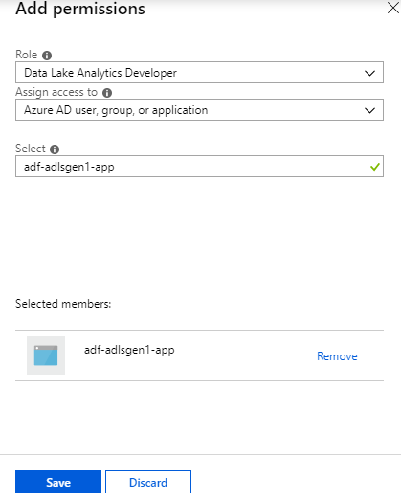

#### ****Permissions — Step 3****

In the previous step we added Azure resource permissions. We now need to add the registered user to the Data Lake instance itself.

Still from within the **Data Lake Analytics** blade select **Add user wizard,**the registered app and click**Select**:

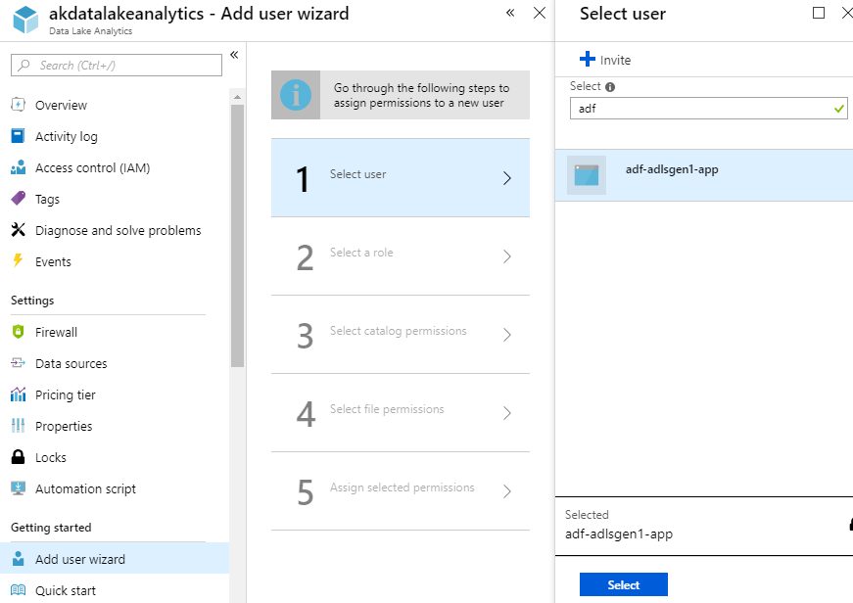

Select the **Data Lake Analytics Developer** role:

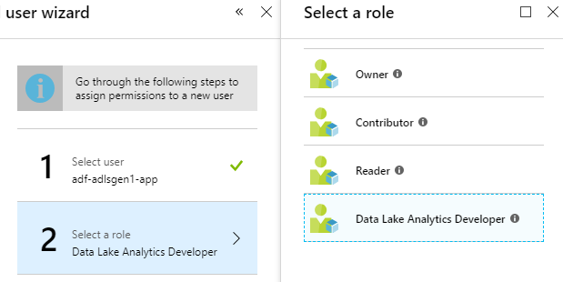

Ensure the catalog permissions for the **database** are set to **Read and Write**and click**Select:**

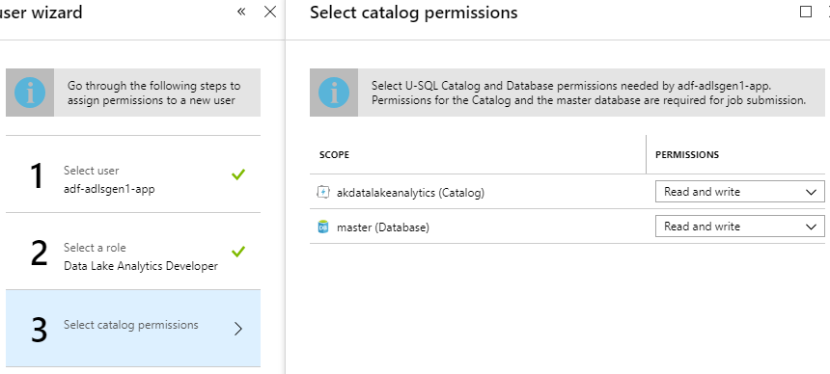

On the **Select file permissions** step ensure **apply to** is set to **This folder and all children**, click**Select**:

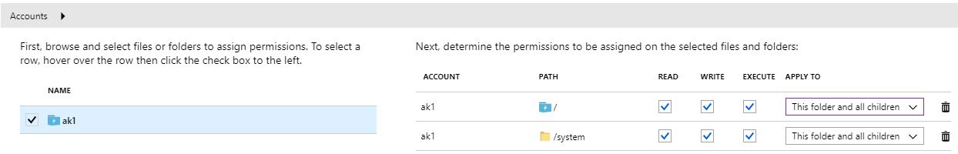

We now need to apply the previously selected permissions. Click **Run** and wait for the job to finish**:**

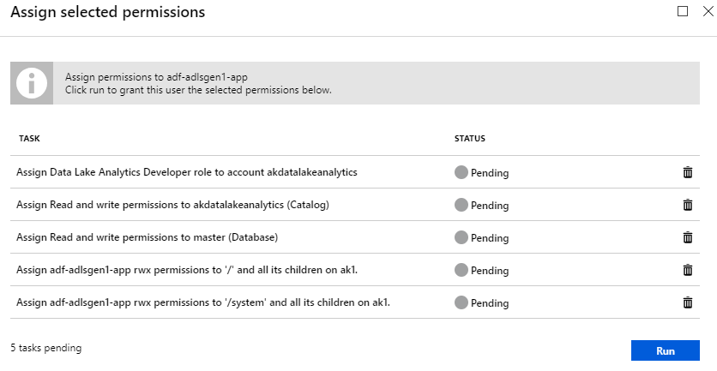

Result, we are now finished with permissions! Click **Done** to close the blade:

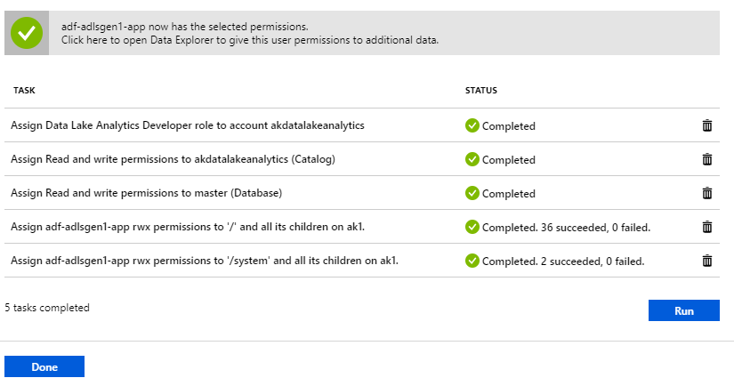

Let’s retest our Linked Service!

Within Data Factory reopen the Linked Service we created previously (the pencil icon):

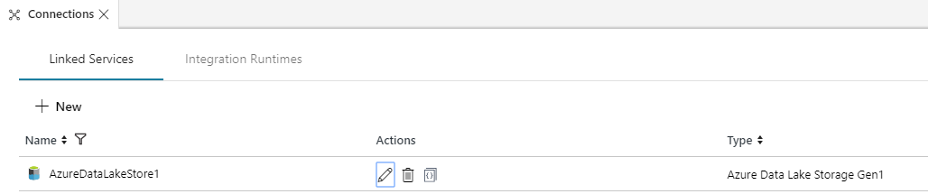

Click **Test Connection** and confirm everything is working:

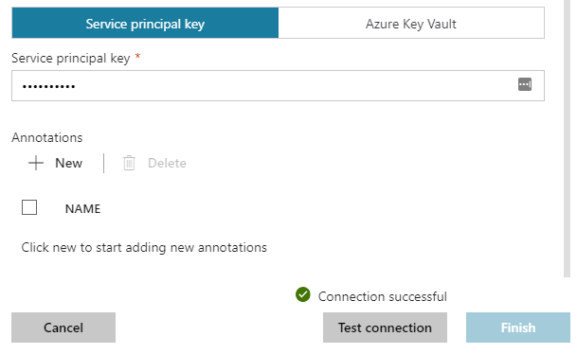

### ****Summary****

I hope you found this useful. The various Azure documentation pages hint at what’s required but don’t provide an end-to-end view of the steps.

In summary these are -

1. Create Linked Service within Data Factory
2. Create the Service Principal within Azure AD
3. Add the Service Principal details to the ADF Linked Service
4. Within Azure AD, assign Data Lake permissions
5. Within Data Lake Analytics, grant developer permissions to the SPN
6. Within Data Lake Analytics, use the Add user wizard to grant catalog permissions
7. Test!